**A REPORT**

**ON**

**Mercedes-Benz Greener Manufacturing:**

**Cutting the Time a Mercedes-Benz Spends on The Test Bench**



BY

RAHUL SINGHAL

Contents

AI in Manufacturing Industry

ML in Automotive Industry

Autonomous Driving

Automobile Testing

Case Study: Mercedes-Benz Greener Manufacturing

**1** Data Description

**2** Features of data

**3** Data analysis

**4** Observations of Target Variable y

**5** XGboost Regression model

**6** Observations

**7** Deep Learning MLP model

**8** Observations

**9** Stacked Regression Model

**10** Results

**11** Comparisons of all models used

**12** Conclusions

Conclusion

**How is AI Used in Manufacturing Industry Now?**

Manufacturing is one of the main industries that uses Artificial Intelligence and Machine Learning technologies to its fullest potential. Smart Factories have major cuts in unexpected downtime and better design of products, as well as improved efficiency and transition times, overall product quality, and worker safety. Artificial Intelligence is delivering more productivity while staying environmentally friendly.

Siemens, GE, Fanuc, Kuka, Bosch, Microsoft, and NVIDIA, among other industry giants are already heavily investing in manufacturing AI with Machine Learning approaches to boost every part of manufacturing.

**How Can AI Help Manufacturing?**

1. Smart Maintenance

Sustenance of machinery is one of the largest expenditures in the industry. That’s why predictive maintenance became an essential solution that will aid in saving a tremendous amount of money. Complex AI algorithms are generating accurate predictions regarding the status of assets and machinery. The Remaining Useful Life (RUL) of equipment becomes naturally longer.

1. Better Product Development

Generative design is an approach that helps to put a detailed brief created by humans into an AI algorithm. The data in the brief can contain various parameters. The algorithm studies all probable variations and comes up with a few optimal answers. This set of answers can be evaluated by pre-trained deep learning models, which can add further insights and help choose certain options.

1. Improvement

Customers expect great products. Also, product faults can cause recalls, which greatly damages the reputation of the brand. AI can alert brands to problems in the production process that can cause quality issues. These problems could be major or subtle, but they all dominate the overall level of production and could be removed in the early stages.

1. Market Adaptation

AI and ML can also help supply chains, Thus, managers can better their strategic vision by using AI suggestions. Estimates are produced by AI based on linking factors such as political situations, weather, consumer behavior, and the economy. Staff, inventory, and supply of materials can be determined according to predictions.

**Machine Learning within the Automotive Industry**

Most manufacturing operations in automotive industries are still largely hooked on experience-based human decisions. The emergence of machine learning in automotive companies is resulting in an increased level of accuracy in decision-making and improved performance. The automotive industry faces a dynamic set of challenges. It’s needless to mention that the automotive industry is on the brink of a revolution.

1. Quality Control

Image recognition and anomaly detection are sorts of machine learning algorithms which can quickly detect and eliminate faulty parts before they get into the vehicle manufacturing workflow. Parts manufacturers can capture images of every component as it is produced, and automatically run those images through a machine learning model to spot any flaws. Eliminating or re-working faulty parts at this stage is far less expensive than discovering and having to repair them later.

1. Root Cause Analysis

ML techniques can vastly accelerate root cause analysis and speed resolution. With traditional methods, it’s also incredibly hard. Anomaly detection algorithms can analyze huge amounts of system and driver data efficiently. They can perform this analysis using additional data types and in far greater quantities than traditional methods.

1. Predictive Maintenance

Machine learning can provide much more precise and — importantly — evolving maintenance recommendations to assist drivers protect their vehicle investment and their safety. Predictive maintenance helps increase customer satisfaction and brand reputation, while also improving compliance with recommended maintenance. It can also be a source of further revenue for car makers as an added-value service.

1. Supply Chain Optimization

Throughout the supply chain, analytical models are employed to identify demand levels for various marketing strategies, sale prices, locations and lots of other data points. Ultimately, this predictive analysis dictates the inventory levels needed at different facilities. Data scientists constantly test different scenarios to make ideal inventory levels sure and improve brand reputation while minimizing unnecessary holding costs.

**Autonomous Driving**

Advantages

* Avoiding traffic collisions caused by human driver errors
* Increase in roadway capacity and reduction in traffic congestion
* Removal of constraints on occupants state
* Reducing the need for traffic police and premium on vehicle insurance
* Reduction in car theft, due to the vehicle's increased awareness

Disadvantages

* Driver's re-education, Liability for damage
* The cost of implementing the new technology could be out of reach
* Security issues, car accident as things could malfunction
* Loss of driver-related jobs
* Heavy reliance on tech
* People who enjoy driving and racing would be disinterested

**Automobile Testing**

Manufacturers need to test the quality of each automotive component because a minor mistake can become a major risk. The quality can be determined by using high-quality testing instruments. Let’s discuss the common types of testing performed.

Chemical Testing

It is necessary to perform chemical testing of vehicles components to ascertain easy functioning. Chemical analysis of plastics, metals, and other products are conducted to ensure that the automotive parts that are manufactured adhere to stringent quality standards.

Thermal Shock

Different environmental conditions have different effects on vehicles and their parts. In extremely hot, cold weather conditions, the battery of the vehicles or motor oil can get affected. This helps check whether the part can withstand sudden change in temperatures or not.

Humidity Resistance Test

Automobiles encounter humid weather and high temperatures. Highly simulated corrosive environment for measuring the degree of resistance. An artificial exposure for the automotive parts is created to test the quality and the effect of different weather conditions.

Tensile Strength Test

Automotive parts are subjected to all sorts of stresses. Vehicles require sufficient amount of tensile strength to sustain themselves in the situation of accidents and collisions. Therefore, measuring the tensile strength of every component is a must to ensure the safety of the vehicle as per the industrial standards.

Salt Spray Test

The outer part of the vehicles faces corrosion and deterioration when coming in contact with salty and foggy environments. Salt spray testing is done to measure the degree of resistance of metallic body when possessing against corrosive salts. This test helps to evaluate the suitability of the coatings in the highly corrosive environment.

Thermal Resistance Test

This high-temperature environment causes overheating of batteries, excess pressure to the engine, and affects the shielding film on the outer body. This creates the temperature between 20 °C to 1200 °C, to determine the effect of low and high temperatures on the plating and coating of vehicles.

**Case Study: Mercedes-Benz Greener Manufacturing**

Daimler’s Mercedes-Benz vehicles are leaders in the premium vehicle industry. Daimler’s engineers have developed a robust testing system. But, reforming the speed of their testing for so many feasible feature combinations are complicated and time-consuming without a powerful algorithmic approach. As one of the world’s largest maker of premium vehicles, safety and efficiency are essential on Daimler’s production lines.

In this case, the challenge is to reduce the time that cars spend on the test bench, which consequently will decrease carbon dioxide emissions associated with the testing procedure. All required data is provided by Mercedes-Benz.

**Data Description**

* This dataset contains a set of variables, each representing a custom feature in a Mercedes car. For example, added air suspension, or a head-up display.
* The ground truth is labeled ‘y’ and represents the time (in seconds) that the car took to pass testing for each variable.
* File descriptions: Variables with letters are categorical. Variables with 0/1 are binary values.

**Features of Data**

* ID: ID column of data.
* y: Target Variable.
* X0-X385: Data columns.

**Data Analysis**

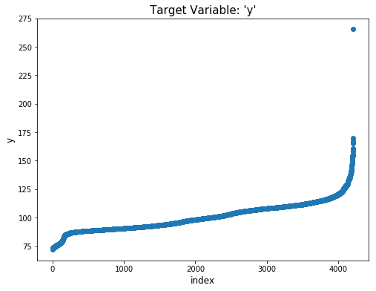

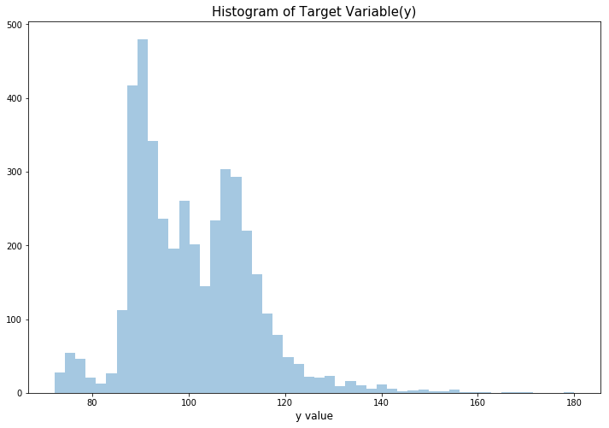

**Observations of Target Variable y**

* We can observe that most of the values lie between 90–120. So average production time is 90–120.
* So, we have a pretty standard distribution here, which is centered around almost exactly 100.
* The fact that ID is not equal to the row ID seems to suggest that the train and test sets are randomly sampled.

**XGboost Regression model**

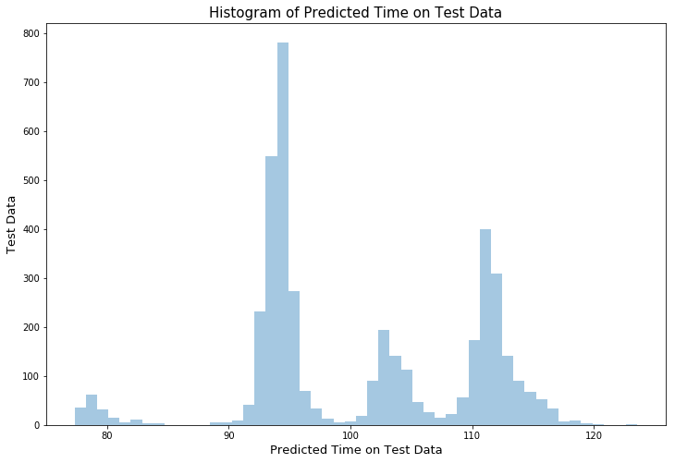

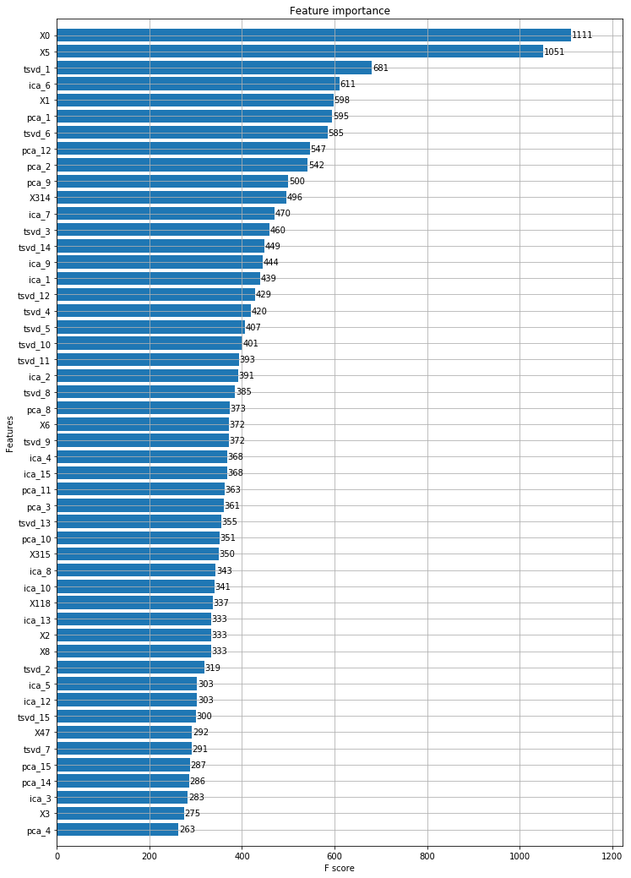

**Observations**

* Categorical features X0 & X5 are highly important in the prediction of our XGBoost model.
* TSVD, PCA & ICA generated features are also contributing effectively in the prediction.
* We can also drop the features that are less important to increase the model effectivity/time to predict target Variable.

**Deep Learning MLP Model**

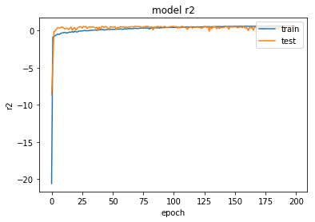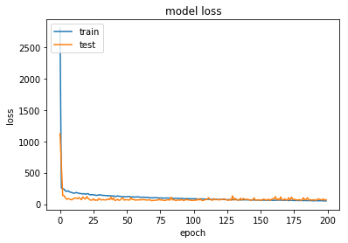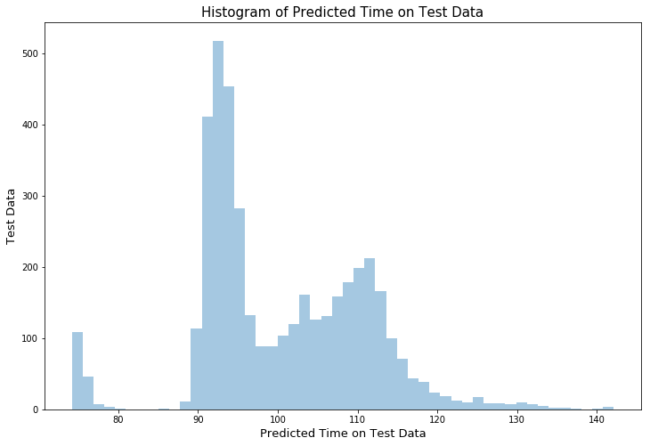

**Observations**

* We can easily see that the model is predicting the Target variable brilliantly.
* The Loss & R2 metric graphs converge after a few epochs.
* No Over-fitting.

**Stacked Regression model**

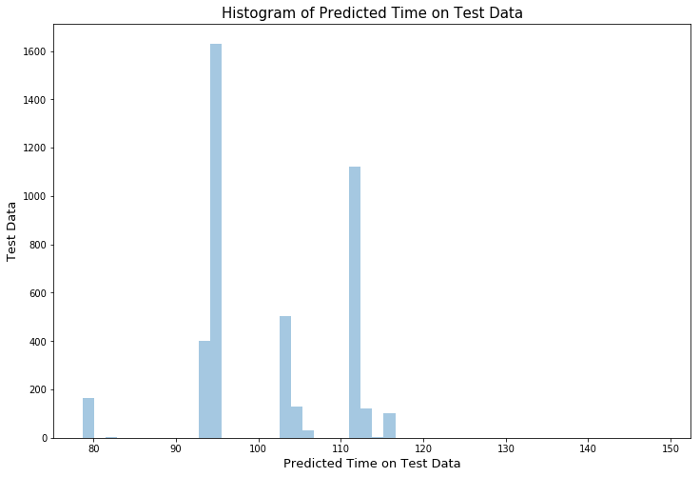

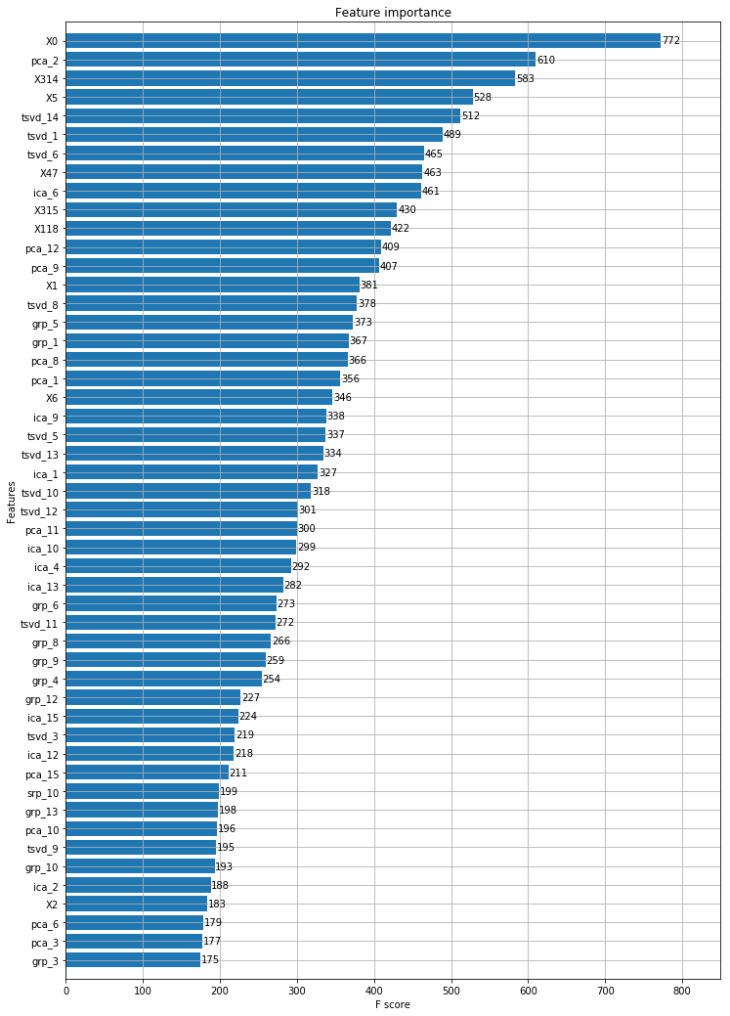

**Results**

* We have pretty decent values of the Train & Test error parameter (RMSE).
* Model is performing nicely & not overfitting.
* R2 score: 0.6805083932610694

**Comparison of All Models We Used**

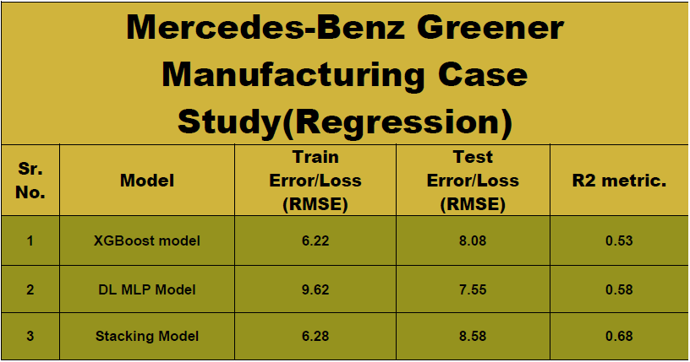

**Conclusions**

* We have collected the Mercedes-Benz Greener Manufacturing data & applied tested ML & DL models on the data.
* The stacking model gives the best performance on the dataset.
* The reason why Stacking models are so popular with Data Science Competitors is evident.

**CONCLUSION**

This project turned out to be a valuable experience in machine learning. The theory of how the data analysis should be carried out and the things that can go wrong in the process were experienced first-hand. Many little challenges were encountered and the understanding of why managing data is not an easy task grew during this project.

Developing a model for Machine Learning is a complicated process and developing a conclusion that gave valuable lessons in managing time, understanding and capturing requirements, defining the scope, estimating task completion, evaluating and thorough testing and mitigating the changing requirements.